**[WIFI Hacking With Kali Linux](http://pakihunter19.blogspot.com/2015/10/wifi-hacking-with-kali-linux.html)**

Start Kali Linux and login, preferably as root.

[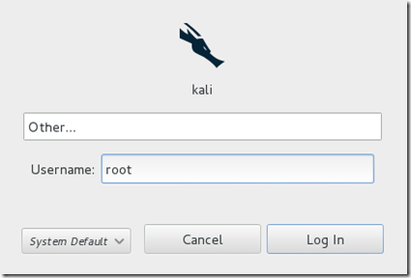](http://lh3.ggpht.com/-2X1wOzTj5Og/U4uKwSnuYoI/AAAAAAAAA4A/LbYujm5g8WE/s1600-h/Step-13.png)

**Step Two:**

Plugin your injection-capable wireless adapter, (Unless your computer card supports it). If you’re using Kali in VMware, then you might have to connect the card via the [image](http://lh5.ggpht.com/-gTb4NktsTy0/U4uK9KyF_VI/AAAAAAAAA4Q/qWzlsaMhXSI/s1600-h/image6.png)icon in the device menu.

**Step Three:**

Disconnect from all wireless networks, open a Terminal, and type **airmon-ng**

[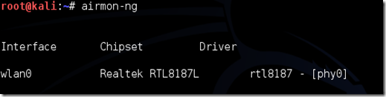](http://lh6.ggpht.com/-9k18vyy7ZR8/U4uK_l08t_I/AAAAAAAAA4g/z3XPgWEM7Vw/s1600-h/Step-33.png)

This will list all of the wireless cards that support monitor (not injection) mode. If no cards are listed, try disconnecting and reconnecting the card and check that it supports monitor mode. You can check if the card supports monitor mode by typing **ifconfig**in another terminal, if the card is listed in ifconfig, but doesn’t show up in airmon-ng, then the card doesn’t support it.  
You can see here that my card supports monitor mode and that it’s listed as **wlan0**.

**Step Four:**

Type **airmon-ng start**followed by the interface of your wireless card. mine is **wlan0**, so my command would be: **airmon-ng start wlan0**

[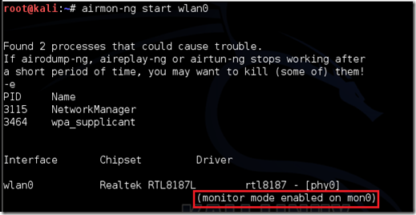](http://lh6.ggpht.com/-EcGoNsMYyBI/U4uLB6OLv4I/AAAAAAAAA4w/iCJEnVfFcxI/s1600-h/Step-43.png)

The “(monitor mode enabled)” message means that the card has successfully been put into monitor mode. Note the name of the new monitor interface, **mon0**.

**EDIT:**A bug recently discovered in Kali Linux makes airmon-ng set the channel as a fixed “**-1**” when you first enable **mon0**. If you receive this error, or simply do not want to take the chance, follow these steps after enabling **mon0:**

Type: **ifconfig [interface of wireless card] down** and hit Enter.  
Replace **[interface of wireless card]** with the name of the interface that you enabled mon0 on; probably called **wlan0**. This disables the wireless card from connecting to the internet, allowing it to focus on monitor mode instead.  
After you have disabled **mon0**(completed the wireless section of the tutorial), you’ll need to enable **wlan0**(or name of wireless interface), by typing: **ifconfig [interface of wireless card] up**and pressing Enter.

**Step Five:**

Type **airodump-ng**followed by the name of the new monitor interface, which is probably**mon0**.

[Step 5](http://lh3.ggpht.com/-KGSm28FiJTI/U4uLDzHU-FI/AAAAAAAAA5A/U6gRmupSPg4/s1600-h/Step-53.png)

If you receive a “**fixed channel –1”**error, see the [Edit](http://lewiscomputerhowto.blogspot.com/2014/06/how-to-hack-wpawpa2-wi-fi-with-kali.html#edit1) above.

**Step Six:**

Airodump will now list all of the wireless networks in your area, and lots of useful information about them. Locate your network or the network that you have permission to penetration test. Once you’ve spotted your network on the ever-populating list, hit **Ctrl + C**on your keyboard to stop the process. Note the channel of your target network.

[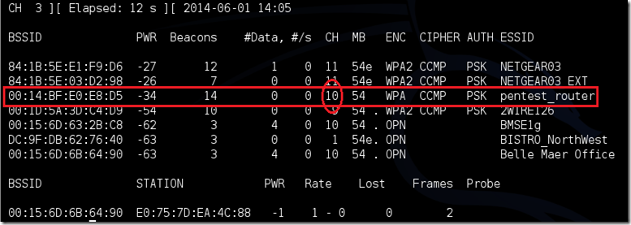](http://lh4.ggpht.com/-OYo4YIf1o94/U4uLF0mRw2I/AAAAAAAAA5Q/B4fwcXpBPiY/s1600-h/step-64.png)

**Step Seven:**

Copy the BSSID of the target network  
[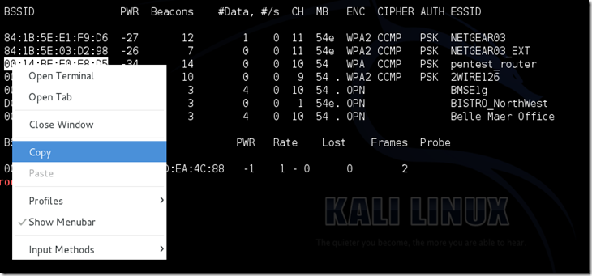](http://lh5.ggpht.com/-MG4nJ5vQzPE/U4uLH8Ca2mI/AAAAAAAAA5g/_tZVPTwgV2w/s1600-h/Step-74.png)  
Now type this command:  
**airodump-ng -c [channel] --bssid [bssid] -w /root/Desktop/ [monitor interface]**Replace [channel] with the channel of your target network. Paste the network BSSID where [bssid] is, and replace [monitor interface] with the name of your monitor-enabled interface, (**mon0**).  
  
A complete command should look like this:  
**airodump-ng -c 10 --bssid 00:14:BF:E0:E8:D5 -w /root/Desktop/ mon0**

[image](http://lh4.ggpht.com/-qVeUdgNFKCY/U4uL1mLaEWI/AAAAAAAAA5s/YU-WQupxvFE/s1600-h/image%25255B19%25255D.png)

Now press enter.

**Step Eight:**

Airodump with now monitor only the target network, allowing us to capture more specific information about it. What we’re really doing now is waiting for a device to connect or reconnect to the network, forcing the router to send out the four-way handshake that we need to capture in order to crack the password.  
Also, four files should show up on your desktop, this is where the handshake will be saved when captured, so don’t delete them!

But we’re not really going to wait for a device to connect, no, that’s not what impatient hackers do. We’re actually going to use another cool-tool that belongs to the aircrack suite called aireplay-ng, to speed up the process. Instead of waiting for a device to connect, hackers use this tool to force a device to reconnect by sending deauthentication (deauth) packets to the device, making it think that it has to reconnect with the router.

Of course, in order for this tool to work, there has to be someone else connected to the network first, so watch the airodump-ng and wait for a client to show up. It might take a long time, or it might only take a second before the first one shows. If none show up after a lengthy wait, then the network might be empty right now, or you’re to far away from the network.  
  
You can see in this picture, that a client has appeared on our network, allowing us to start the next step.

[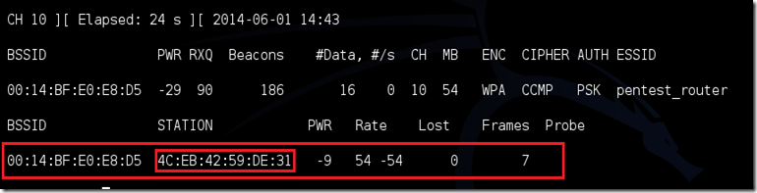](http://lh4.ggpht.com/-NE9FtHFE43U/U4uL3Yf7MwI/AAAAAAAAA6A/q0yU5o1QCRQ/s1600-h/Step-88.png)

**Step Nine:**

leave **airodump-ng**running and open a second terminal. In this terminal, type this command:  
**aireplay-ng –0 2 –a [router bssid] –c [client bssid] mon0**The **–0** is a short cut for the deauth mode and the **2** is the number of deauth packets to send.  
**-a** indicates the access point (router)’s bssid, replace [router bssid] with the BSSID of the target network, which in my case, is 00:14:BF:E0:E8:D5.  
**-c** indicates the clients BSSID, noted in the previous picture. Replace the [client bssid] with the BSSID of the connected client, this will be listed under “STATION.”  
And of course, **mon0** merely means the monitor interface, change it if yours is different.

My complete command looks like this:  
**aireplay-ng –0 2 –a 00:14:BF:E0:E8:D5 –c 4C:EB:42:59:DE:31 mon0**

[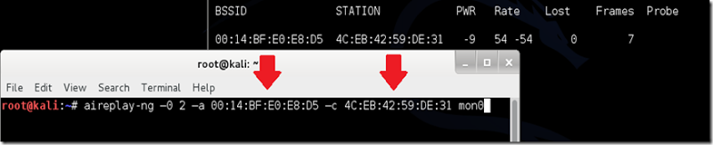](http://lh3.ggpht.com/-Sm-BO4gRb4E/U4uL5HIn0GI/AAAAAAAAA6Q/lL46A25bric/s1600-h/Step-93.png)

**Step Ten:**

Upon hitting Enter, you’ll see aireplay-ng send the packets, and within moments, you should see this message appear on the airodump-ng screen!  
[image](http://lh3.ggpht.com/-V609sD4t_ks/U4uL6u3BU_I/AAAAAAAAA6g/n2zCYn5qiu0/s1600-h/image13.png)

[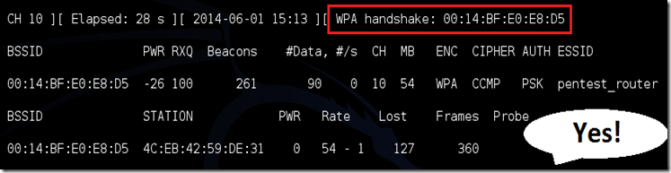](http://lh3.ggpht.com/-niFsQeFzdT8/U4uL8wX8ICI/AAAAAAAAA6w/rHZPO94Ya-s/s1600-h/step-104.png)

This means that the handshake has been captured, the password is in the hacker’s hands, in some form or another. You can close the aireplay-ng terminal and hit **Ctrl + C**on the airodump-ng terminal to stop monitoring the network, but don’t close it yet just incase you need some of the information later.

**Step 11:**

This concludes the external part of this tutorial. From now on, the process is entirely between your computer, and those four files on your Desktop. Actually, the .cap one, that is important. Open a new Terminal, and type in this command:  
**aircrack-ng -a2 -b [router bssid] -w [path to wordlist] /root/Desktop/*.cap**

**-a**is the method aircrack will use to crack the handshake, 2=WPA method.  
**-b**stands for bssid, replace [router bssid] with the BSSID of the target router, mine is 00:14:BF:E0:E8:D5.  
**-w**stands for wordlist, replace [path to wordlist] with the path to a wordlist that you have downloaded. I have a wordlist called “wpa.txt” in the root folder.  
**/root/Desktop/*.cap** is the path to the .cap file containing the password,the **\***means wild card in Linux, and since I’m assuming that there are no other .cap files on your Desktop, this should work fine the way it is.

My complete command looks like this:  
**aircrack-ng –a2 –b 00:14:BF:E0:E8:D5 –w /root/wpa.txt  /root/Desktop/*.cap  
[image](http://lh3.ggpht.com/-2J4AcKDhuQY/U4uL_irBF5I/AAAAAAAAA7I/2pLDu-HUiUo/s1600-h/image%25255B7%25255D.png)**

Now press Enter.

**Step 12:**

Aircrack-ng will now launch into the process of cracking the password. However, it will only crack it if the password happens to be in the wordlist that you’ve selected. Sometimes, it’s not. If this is the case, then you can congratulate the owner on being “Impenetrable,” of course, only after you’ve tried every wordlist that a hacker might use or make!

Cracking the password might take a long time depending on the size of the wordlist. Mine went very quickly.

If the phrase is in the wordlist, then aircrack-ng will show it too you like this:  
  
[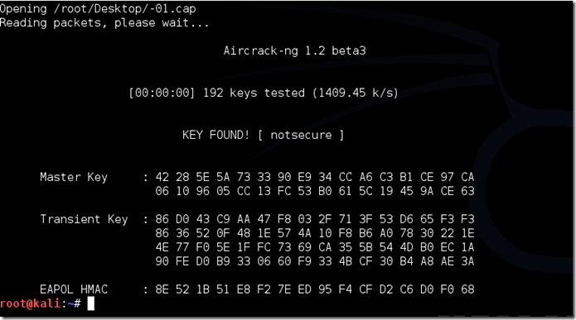](http://lh5.ggpht.com/-3lNdA9sGt0c/U4uMBXywb0I/AAAAAAAAA7Y/qUPycKSdAec/s1600-h/image%25255B11%25255D.png)

The passphrase to our test-network was “notsecure,” and you can see here that aircrack found it.

If you find the password without a decent struggle, then change your password, if it’s your network. If you’re penetration testing for someone, then tell them to change their password as soon as possible.